Load Test Report

## Load Details

Stack: S1

Stack Url: https://jupiter.uptycs.net/

Sprint: 138

Build: 138005

Load Name: MultiCustomer

Load Duration In Hrs: 10 hrs

Load Start Time Ist: 2023-08-24 00:33

Load End Time Ist: 2023-08-24 10:33

Customers: 120

Number Of Customers With Auto Exception Enabled: 0

Test Type: Rule Engine Load and Control Plane Load

Customer: Multiple

Total Assets: 80K Control Plane +15K Multi customer

Records Sent Per Hour Per Customer: 8164800

Records Sent Per Hour: 979776000 (979 million)

Input File: rhel7-6tab_12rec.log

Events Table Name: dns_lookup_events, socket_events, process_events, process_file_events

### Test Environment details

|  |  |  |  |  |
| --- | --- | --- | --- | --- |
| node | cluster | cores | ram | storage |
| s1c1pn1 | 1 | 32 | 188 | root_partition:365G, kafka:3.6T, |
| s1c1pn2 | 1 | 32 | 188 | root_partition:365G, kafka:3.6T, |
| s1c1pn3 | 1 | 32 | 188 | root_partition:365G, kafka:3.6T, |
| s1c1pn4 | 1 | 32 | 188 | root_partition:365G, kafka:3.6T, |
| s1c1pn5 | 1 | 32 | 188 | root_partition:365G, kafka:3.6T, |
| s1c1pn6 | 1 | 32 | 188 | root_partition:365G, kafka:3.6T, |
| s1c2pn1 | 2 | 32 | 188 | root_partition:365G, kafka:3.6T, |
| s1c2pn2 | 2 | 32 | 188 | root_partition:365G, kafka:3.6T, |
| s1c2pn3 | 2 | 32 | 188 | root_partition:365G, kafka:3.6T, |
| s1c2pn4 | 2 | 32 | 188 | root_partition:365G, kafka:3.6T, |
| s1c2pn5 | 2 | 32 | 188 | root_partition:365G, kafka:3.6T, |
| s1c2pn6 | 2 | 32 | 188 | root_partition:365G, kafka:3.6T, |
| s1c1dn1 | 1 | 32 | 251 | root_partition:365G, spark:3.6T, dn1:3.6T, dn2:3.6T, dn3:3.6T, |
| s1c1dn2 | 1 | 32 | 251 | root_partition:365G, spark:3.6T, dn1:3.6T, dn2:3.6T, dn3:3.6T, |
| s1c1dn3 | 1 | 32 | 251 | root_partition:365G, spark:3.6T, dn1:3.6T, dn2:3.6T, dn3:3.6T, |
| s1c1dn4 | 1 | 32 | 188 | root_partition:365G, spark:3.6T, dn1:3.6T, dn2:3.6T, dn3:3.6T, |
| s1c1dn5 | 1 | 32 | 188 | root_partition:365G, spark:3.6T, dn1:3.6T, dn2:3.6T, dn3:3.6T, |
| s1c1dn6 | 1 | 32 | 188 | root_partition:365G, spark:3.6T, dn1:3.6T, dn2:3.6T, dn3:3.6T, |
| s1c2dn1 | 2 | 32 | 251 | root_partition:365G, spark:3.6T, dn1:3.6T, dn2:3.6T, dn3:3.6T, |
| s1c2dn2 | 2 | 32 | 251 | root_partition:365G, spark:3.6T, dn1:3.6T, dn2:3.6T, dn3:3.6T, |
| s1c2dn3 | 2 | 32 | 251 | root_partition:365G, spark:3.6T, dn1:3.6T, dn2:3.6T, dn3:3.6T, |
| s1c2dn4 | 2 | 32 | 188 | root_partition:365G, spark:3.6T, dn1:3.6T, dn2:3.6T, dn3:3.6T, |
| s1c2dn5 | 2 | 32 | 188 | root_partition:365G, spark:3.6T, dn1:3.6T, dn2:3.6T, dn3:3.6T, |
| s1c2dn6 | 2 | 32 | 188 | root_partition:365G, spark:3.6T, dn1:3.6T, dn2:3.6T, dn3:3.6T, |
| s1configdb1 | 1 | 32 | 188 | root_partition:365G, pg:3.5T, data:3.5T, |
| s1configdb2 | 1 | 32 | 188 | root_partition:365G, pg:5.5T, data:5.5T, |
| s1monitor | 1 | 16 | 62 | root_partition:98G, |

## Disk Usages

### KAFKA disk space usage

|  |  |  |  |  |
| --- | --- | --- | --- | --- |
| Node | KAFKA total space configured(TB) | KAFKA disk used % before load | KAFKA disk used % after load | KAFKA used space during load (GB) |
| s1c1pn1 | 3.6 | 11.0 | 2.0 | -331.78 |
| s1c1pn2 | 3.6 | 12.0 | 2.0 | -368.64 |
| s1c1pn3 | 3.6 | 11.0 | 2.0 | -331.78 |
| s1c1pn4 | 3.6 | 12.0 | 2.0 | -368.64 |
| s1c1pn5 | 3.6 | 12.0 | 2.0 | -368.64 |
| s1c1pn6 | 3.6 | 11.0 | 2.0 | -331.78 |
| s1c2pn1 | 3.6 | 10.0 | 1.0 | -331.78 |
| s1c2pn2 | 3.6 | 10.0 | 1.0 | -331.78 |
| s1c2pn3 | 3.6 | 10.0 | 1.0 | -331.78 |
| s1c2pn4 | 3.6 | 10.0 | 1.0 | -331.78 |
| s1c2pn5 | 3.6 | 10.0 | 1.0 | -331.78 |
| s1c2pn6 | 3.6 | 10.0 | 1.0 | -331.78 |

### HDFS disk space usage

|  |  |  |  |  |
| --- | --- | --- | --- | --- |
| Node | HDFS total space configured(TB) | HDFS disk used % before load | HDFS disk used % after load | HDFS used space during load (GB) |
| s1c1dn1 | 11.78 | 6.57 | 6.44 | -15.33 |
| s1c1dn2 | 11.78 | 6.56 | 6.43 | -16.0 |
| s1c1dn6 | 11.78 | 6.53 | 6.39 | -17.36 |
| s1c1dn3 | 11.78 | 6.52 | 6.4 | -14.61 |
| s1c1dn4 | 11.78 | 6.47 | 6.33 | -17.53 |
| s1c2dn2 | 11.78 | 6.46 | 6.3 | -18.97 |
| s1c2dn6 | 11.78 | 6.43 | 6.3 | -15.34 |
| s1c2dn1 | 11.78 | 6.38 | 6.25 | -15.07 |
| s1c2dn4 | 11.78 | 6.33 | 6.23 | -12.81 |

### PG disk space usage

|  |  |  |
| --- | --- | --- |
| partition | master configdb node | standby configdb node |
| /pg | 7.2G | 7.5G |
| /data | 31G | 32G |

### Kafka topics

|  |
| --- |
| 138005 |
| Summary : New topics found |
| New Topics : __consumer_offsets __debezium-heartbeat.cdc __debezium-heartbeat.statedb agentghquery agentkubequery agentlesslog agentlesslogdecorator agentoktaquery agentosquery alert alert_replay api asset-capability assetgroup1 audit auto-exception az_events_blob bulk_replay cdc.public.alerts cdc.public.asset_cloud_infos cdc.public.asset_tags cdc.public.assets cdc.public.cloud_accounts cdc.public.customer_database cdc.public.customers cdc.public.incidents cdc.public.object_groups cdc.public.user_object_groups cdc.public.users cloudconnectorsink cloudqueryVuln cloudqueryevents cloudqueryinventory cloudtrail_objects compliance compliance_summary containers cqazevents cqcloudtrail cqcloudtrail_data_sink cqcloudtrail_ro_sink debezium_configs debezium_offsets debezium_statedb_configs debezium_statedb_offsets debezium_statedb_status_storage debezium_status_storage decorators detection ephermalresources epsink event event_cloud event_replay gcp_cloudlog_objects managedavtables notifications op osquery_cli_tags prestoquerylogs querypack realtimequery registryevent reportschedule1 scan_summary sidequerydecorator slackuser1 state statedb.public.containers_current statedb.public.kubernetes_nodes_current statedb.public.kubernetes_pods_containers_current statedb.public.kubernetes_pods_current statedb.public.vulnerabilities_scanned_images tag1 threat_indicators unified_dashboard uptycs-cloud-remediation vulnerabilities vulntickets |
| Old Topics : |

## Charts

### Live assets

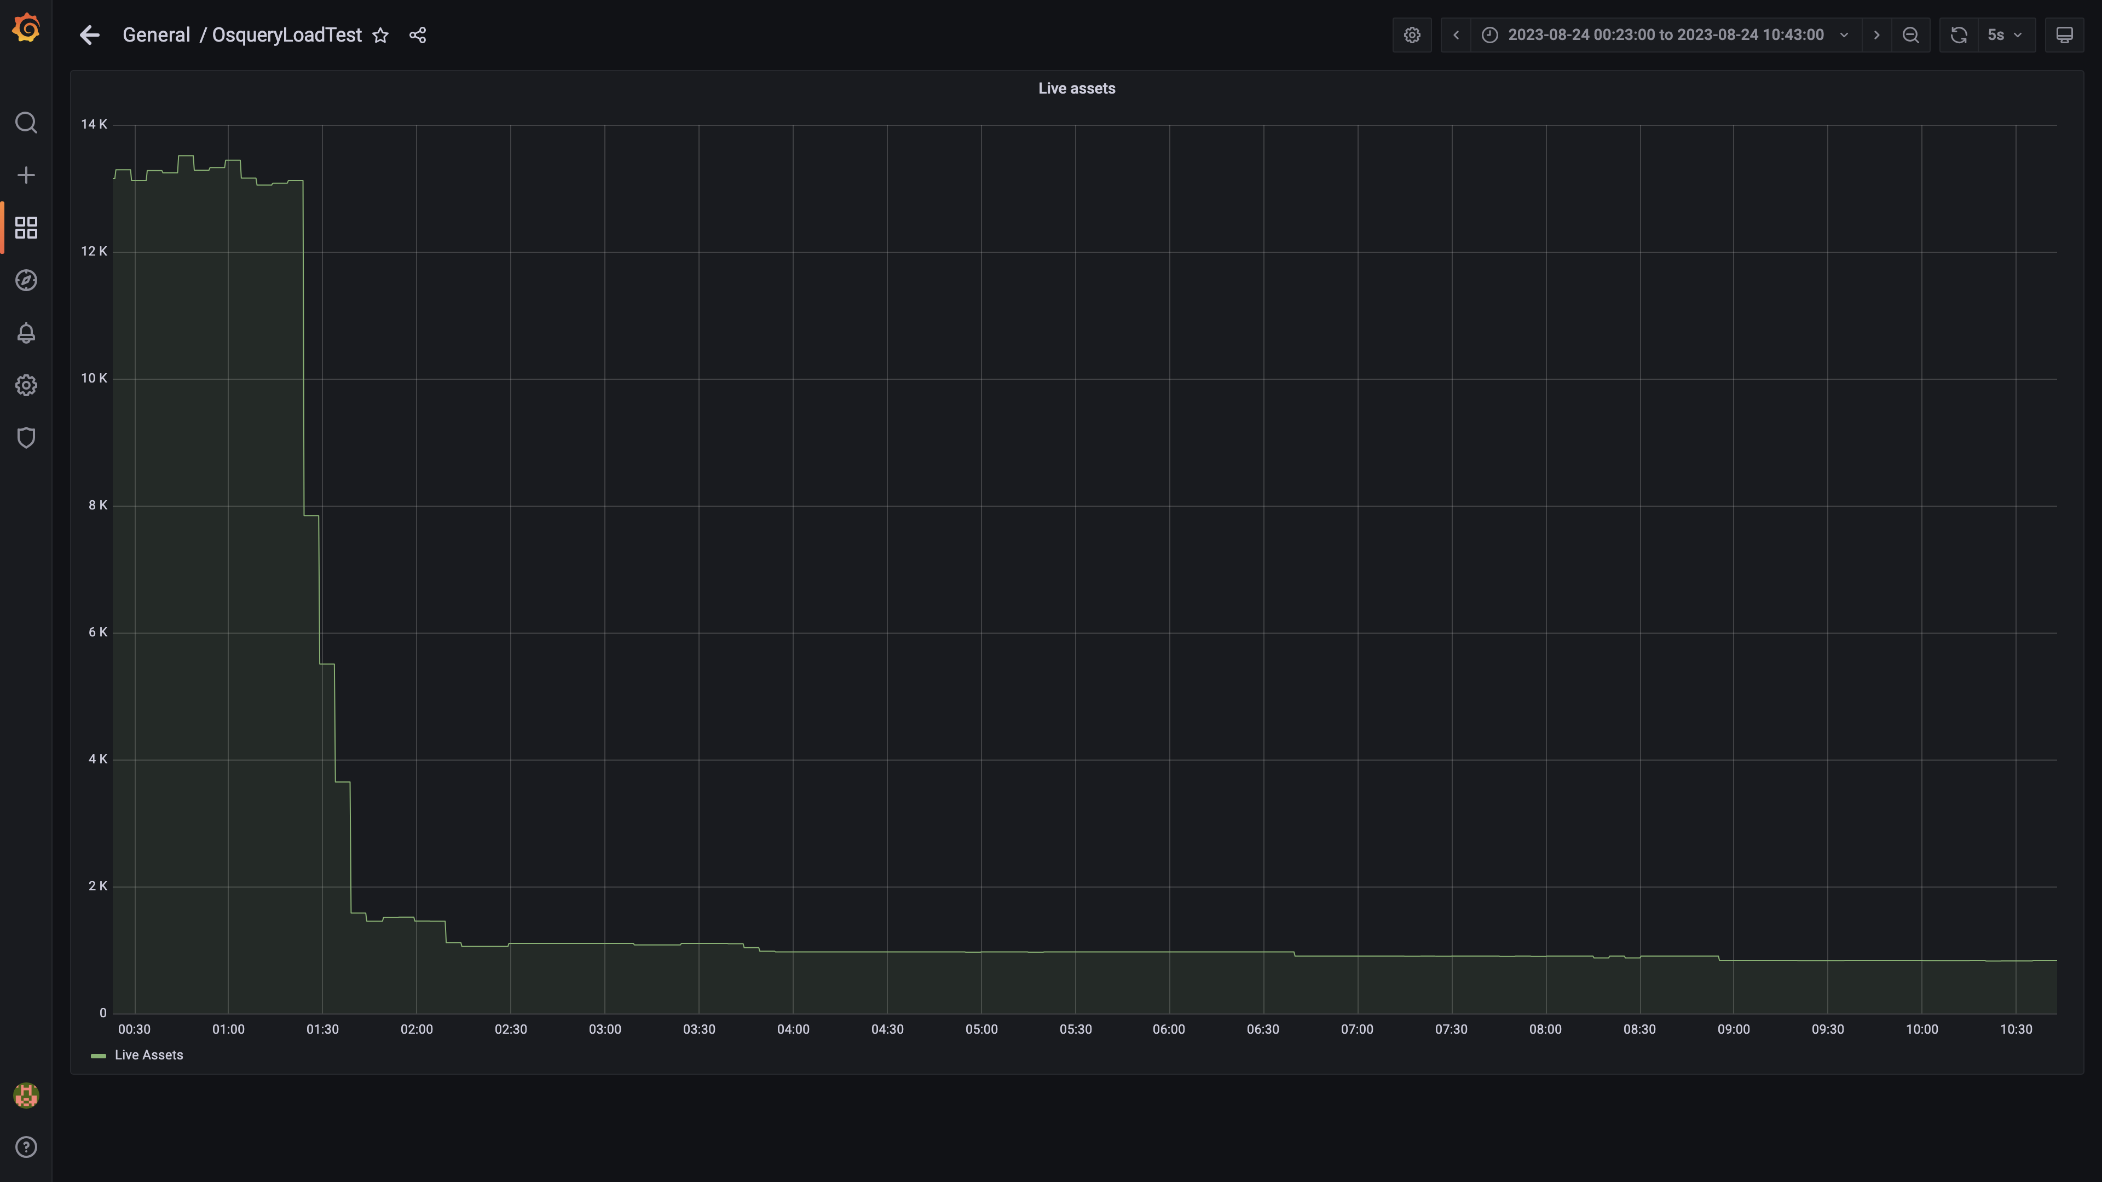

### Kafka lag for all groups

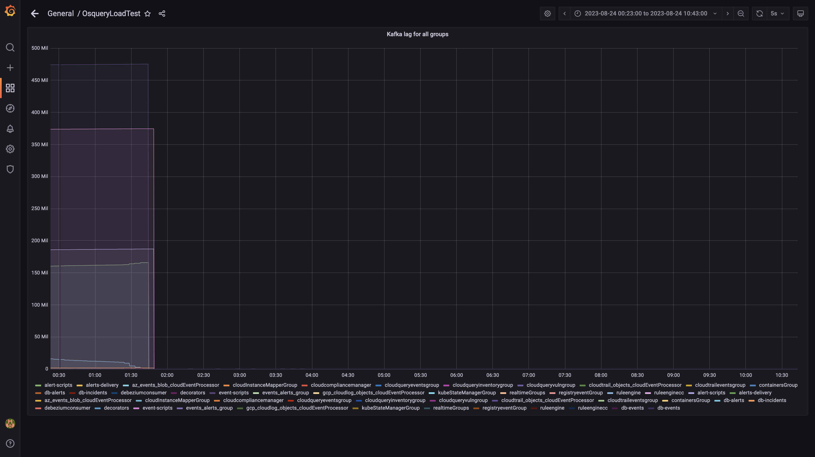

### Compaction status

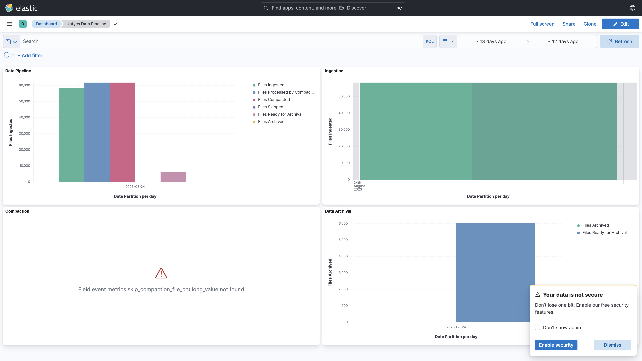

## Average Resource Utilization

### Comparision of Average Memory utilization

|  |  |  |  |  |
| --- | --- | --- | --- | --- |
| Metric | 137006 | 138005 | Absolute(%) | Relative(%) |
| Memory used by s1c1dn1 | 79.02% | 63.83% | 15.19% ⬇️ | 19.22% ⬇️ |
| Memory used by s1c1dn2 | 66.60% | 56.83% | 9.77% ⬇️ | 14.67% ⬇️ |
| Memory used by s1c1dn3 | 67.26% | 56.20% | 11.06% ⬇️ | 16.45% ⬇️ |
| Memory used by s1c1dn4 | 74.22% | 58.77% | 15.45% ⬇️ | 20.81% ⬇️ |
| Memory used by s1c1dn5 | 72.73% | 53.67% | 19.07% ⬇️ | 26.22% ⬇️ |
| Memory used by s1c1dn6 | 74.27% | 56.70% | 17.57% ⬇️ | 23.66% ⬇️ |
| Memory used by s1c1pn1 | 39.81% | 37.11% | 2.70% ⬇️ | 6.79% ⬇️ |
| Memory used by s1c1pn2 | 29.91% | 23.89% | 6.02% ⬇️ | 20.13% ⬇️ |
| Memory used by s1c1pn3 | 36.71% | 37.00% | 0.29% ⬆️ | 0.79% ⬆️ |
| Memory used by s1c1pn4 | 36.04% | 39.16% | 3.12% ⬆️ | 8.65% ⬆️ |
| Memory used by s1c1pn5 | 40.29% | 35.87% | 4.43% ⬇️ | 10.99% ⬇️ |
| Memory used by s1c1pn6 | 36.03% | 32.03% | 4.00% ⬇️ | 11.09% ⬇️ |
| Memory used by s1c2dn1 | 57.63% | 47.66% | 9.97% ⬇️ | 17.29% ⬇️ |
| Memory used by s1c2dn2 | 54.76% | 43.98% | 10.78% ⬇️ | 19.68% ⬇️ |
| Memory used by s1c2dn3 | 54.48% | 41.62% | 12.86% ⬇️ | 23.61% ⬇️ |
| Memory used by s1c2dn4 | 67.89% | 51.34% | 16.55% ⬇️ | 24.38% ⬇️ |
| Memory used by s1c2dn5 | 67.85% | 49.68% | 18.17% ⬇️ | 26.78% ⬇️ |
| Memory used by s1c2dn6 | 68.61% | 52.32% | 16.29% ⬇️ | 23.74% ⬇️ |
| Memory used by s1c2pn1 | 32.91% | 32.90% | 0.01% ⬇️ | 0.04% ⬇️ |
| Memory used by s1c2pn2 | 30.89% | 32.77% | 1.87% ⬆️ | 6.07% ⬆️ |
| Memory used by s1c2pn3 | 30.54% | 32.18% | 1.64% ⬆️ | 5.38% ⬆️ |
| Memory used by s1c2pn4 | 30.61% | 35.12% | 4.52% ⬆️ | 14.76% ⬆️ |
| Memory used by s1c2pn5 | 35.75% | 35.89% | 0.14% ⬆️ | 0.40% ⬆️ |
| Memory used by s1c2pn6 | 34.75% | 32.42% | 2.34% ⬇️ | 6.73% ⬇️ |
| Memory used by s1cloudquery | - | 8.17% | - | - |
| Memory used by s1configdb1 | 14.92% | 9.65% | 5.27% ⬇️ | 35.31% ⬇️ |
| Memory used by s1configdb2 | 1.21% | 1.63% | 0.42% ⬆️ | 34.94% ⬆️ |
| Memory used by s1elasticsearch | - | 27.31% | - | - |
| Memory used by s1kibana | - | 4.27% | - | - |
| Memory used by s1logstash1 | - | 15.75% | - | - |
| Memory used by s1logstash2 | - | 15.46% | - | - |
| Memory used by s1mlnode1 | - | 11.58% | - | - |
| Memory used by s1mlnode2 | - | 5.16% | - | - |
| Memory used by s1monitor | 26.52% | 39.70% | 13.18% ⬆️ | 49.71% ⬆️ |
| Memory used by s1stsnode1 | - | 82.70% | - | - |
| Memory used by s1stsnode2 | - | 7.13% | - | - |
| Memory used by s1stsnode3 | - | 6.93% | - | - |
| Memory used by Rule Engine s1c1pn1 | 6.79% | 7.78% | 0.99% ⬆️ | 14.54% ⬆️ |
| Memory used by Rule Engine s1c1pn3 | 6.58% | 7.31% | 0.73% ⬆️ | 11.12% ⬆️ |
| Memory used by Rule Engine s1c1pn4 | 6.60% | 7.40% | 0.80% ⬆️ | 12.08% ⬆️ |
| Memory used by Rule Engine s1c1pn5 | 6.63% | 7.91% | 1.27% ⬆️ | 19.17% ⬆️ |
| Memory used by Rule Engine s1c1pn6 | 6.57% | 6.96% | 0.38% ⬆️ | 5.84% ⬆️ |
| Memory used by Rule Engine s1c2pn1 | 6.23% | 8.26% | 2.03% ⬆️ | 32.60% ⬆️ |
| Memory used by Rule Engine s1c2pn2 | 6.38% | 7.69% | 1.31% ⬆️ | 20.60% ⬆️ |
| Memory used by Rule Engine s1c2pn3 | 6.29% | 7.84% | 1.55% ⬆️ | 24.66% ⬆️ |
| Memory used by Rule Engine s1c2pn4 | 6.26% | 7.95% | 1.68% ⬆️ | 26.89% ⬆️ |
| Memory used by Rule Engine s1c2pn5 | 6.34% | 8.52% | 2.18% ⬆️ | 34.29% ⬆️ |
| Memory used by Rule Engine s1c2pn6 | 6.19% | 7.61% | 1.42% ⬆️ | 22.89% ⬆️ |
| Memory used by Osquery Ingestion s1c1dn1 | 8.60% | 5.68% | 2.92% ⬇️ | 33.99% ⬇️ |
| Memory used by Osquery Ingestion s1c1dn2 | 8.39% | 6.57% | 1.82% ⬇️ | 21.68% ⬇️ |
| Memory used by Osquery Ingestion s1c1dn3 | 8.28% | 6.55% | 1.73% ⬇️ | 20.86% ⬇️ |
| Memory used by Osquery Ingestion s1c1dn4 | 11.02% | 8.47% | 2.54% ⬇️ | 23.09% ⬇️ |
| Memory used by Osquery Ingestion s1c1dn5 | 10.98% | 8.85% | 2.13% ⬇️ | 19.39% ⬇️ |
| Memory used by Osquery Ingestion s1c1dn6 | 11.05% | 8.51% | 2.54% ⬇️ | 22.97% ⬇️ |
| Memory used by Osquery Ingestion s1c2dn1 | 8.28% | 4.81% | 3.47% ⬇️ | 41.92% ⬇️ |
| Memory used by Osquery Ingestion s1c2dn2 | 8.04% | 5.40% | 2.64% ⬇️ | 32.85% ⬇️ |
| Memory used by Osquery Ingestion s1c2dn3 | 8.11% | 5.49% | 2.63% ⬇️ | 32.37% ⬇️ |
| Memory used by Osquery Ingestion s1c2dn4 | 10.50% | 7.27% | 3.24% ⬇️ | 30.82% ⬇️ |
| Memory used by Osquery Ingestion s1c2dn5 | 10.65% | 7.68% | 2.97% ⬇️ | 27.93% ⬇️ |
| Memory used by Osquery Ingestion s1c2dn6 | 10.80% | 7.44% | 3.35% ⬇️ | 31.07% ⬇️ |
| Memory used by Kafka s1c1pn1 | 2.83% | 2.64% | 0.19% ⬇️ | 6.67% ⬇️ |
| Memory used by Kafka s1c1pn2 | 3.55% | 3.50% | 0.05% ⬇️ | 1.36% ⬇️ |
| Memory used by Kafka s1c1pn3 | 3.56% | 3.43% | 0.13% ⬇️ | 3.68% ⬇️ |
| Memory used by Kafka s1c1pn4 | 3.56% | 3.42% | 0.15% ⬇️ | 4.15% ⬇️ |
| Memory used by Kafka s1c1pn5 | 3.56% | 3.43% | 0.13% ⬇️ | 3.71% ⬇️ |
| Memory used by Kafka s1c1pn6 | 3.55% | 3.41% | 0.13% ⬇️ | 3.77% ⬇️ |
| Memory used by Kafka s1c2pn1 | 2.90% | 2.59% | 0.31% ⬇️ | 10.70% ⬇️ |
| Memory used by Kafka s1c2pn2 | 3.54% | 3.13% | 0.40% ⬇️ | 11.39% ⬇️ |
| Memory used by Kafka s1c2pn3 | 3.47% | 3.22% | 0.25% ⬇️ | 7.21% ⬇️ |
| Memory used by Kafka s1c2pn4 | 3.54% | 3.41% | 0.13% ⬇️ | 3.76% ⬇️ |
| Memory used by Kafka s1c2pn5 | 3.52% | 3.38% | 0.14% ⬇️ | 4.05% ⬇️ |
| Memory used by Kafka s1c2pn6 | 3.52% | 3.38% | 0.14% ⬇️ | 3.87% ⬇️ |
| Memory used by Trino s1c1dn1 | 23.35% | 16.03% | 7.32% ⬇️ | 31.34% ⬇️ |
| Memory used by Trino s1c1dn2 | 15.39% | 19.21% | 3.83% ⬆️ | 24.88% ⬆️ |
| Memory used by Trino s1c1dn3 | 15.48% | 19.50% | 4.02% ⬆️ | 25.99% ⬆️ |
| Memory used by Trino s1c1dn4 | 16.02% | 20.40% | 4.38% ⬆️ | 27.32% ⬆️ |
| Memory used by Trino s1c1dn5 | 15.89% | 21.10% | 5.21% ⬆️ | 32.79% ⬆️ |
| Memory used by Trino s1c1dn6 | 16.16% | 20.88% | 4.72% ⬆️ | 29.21% ⬆️ |
| Memory used by Trino s1c2dn1 | 15.12% | 24.19% | 9.08% ⬆️ | 60.06% ⬆️ |
| Memory used by Trino s1c2dn2 | 15.47% | 21.15% | 5.68% ⬆️ | 36.72% ⬆️ |
| Memory used by Trino s1c2dn3 | 15.28% | 21.00% | 5.72% ⬆️ | 37.47% ⬆️ |
| Memory used by Trino s1c2dn4 | 16.06% | 22.70% | 6.64% ⬆️ | 41.33% ⬆️ |
| Memory used by Trino s1c2dn5 | 16.23% | 22.68% | 6.44% ⬆️ | 39.68% ⬆️ |
| Memory used by Trino s1c2dn6 | 16.48% | 22.00% | 5.52% ⬆️ | 33.52% ⬆️ |
| Memory used by Tls s1c1pn1 | 0.26% | 0.40% | 0.13% ⬆️ | 50.02% ⬆️ |
| Memory used by Tls s1c1pn3 | 0.27% | 0.55% | 0.28% ⬆️ | 105.15% ⬆️ |
| Memory used by Tls s1c1pn4 | 0.27% | 0.23% | 0.03% ⬇️ | 12.80% ⬇️ |
| Memory used by Tls s1c1pn5 | 0.27% | 0.26% | 0.01% ⬇️ | 3.83% ⬇️ |
| Memory used by Tls s1c1pn6 | 0.27% | 0.27% | 0.00% ⬆️ | 1.52% ⬆️ |
| Memory used by Tls s1c2pn1 | 0.27% | 0.63% | 0.36% ⬆️ | 134.56% ⬆️ |
| Memory used by Tls s1c2pn2 | 0.27% | 0.67% | 0.40% ⬆️ | 147.82% ⬆️ |
| Memory used by Tls s1c2pn3 | 0.27% | 0.27% | 0.00% ⬆️ | 1.51% ⬆️ |
| Memory used by Tls s1c2pn4 | 0.27% | 0.25% | 0.02% ⬇️ | 7.03% ⬇️ |
| Memory used by Tls s1c2pn5 | 0.27% | 0.26% | 0.01% ⬇️ | 3.59% ⬇️ |
| Memory used by EventsDbIngestion s1c1dn1 | 1.79% | 0.61% | 1.18% ⬇️ | 65.81% ⬇️ |
| Memory used by EventsDbIngestion s1c1dn2 | 3.35% | 1.00% | 2.35% ⬇️ | 70.19% ⬇️ |
| Memory used by EventsDbIngestion s1c1dn3 | 3.35% | 1.00% | 2.35% ⬇️ | 70.17% ⬇️ |
| Memory used by EventsDbIngestion s1c1dn4 | 4.45% | 1.39% | 3.06% ⬇️ | 68.74% ⬇️ |
| Memory used by EventsDbIngestion s1c1dn5 | 4.40% | 1.20% | 3.20% ⬇️ | 72.73% ⬇️ |
| Memory used by EventsDbIngestion s1c1dn6 | 4.48% | 1.30% | 3.18% ⬇️ | 71.00% ⬇️ |
| Memory used by EventsDbIngestion s1c2dn1 | 1.88% | 0.58% | 1.29% ⬇️ | 68.92% ⬇️ |
| Memory used by EventsDbIngestion s1c2dn2 | 3.32% | 1.10% | 2.22% ⬇️ | 66.88% ⬇️ |
| Memory used by EventsDbIngestion s1c2dn3 | 3.37% | 1.00% | 2.37% ⬇️ | 70.30% ⬇️ |
| Memory used by EventsDbIngestion s1c2dn4 | 4.49% | 1.40% | 3.09% ⬇️ | 68.81% ⬇️ |
| Memory used by EventsDbIngestion s1c2dn5 | 4.41% | 1.30% | 3.11% ⬇️ | 70.51% ⬇️ |
| Memory used by EventsDbIngestion s1c2dn6 | 4.46% | 1.40% | 3.06% ⬇️ | 68.58% ⬇️ |
| Memory used by Logger s1c1pn2 | 1.20% | 0.29% | 0.91% ⬇️ | 76.05% ⬇️ |
| Memory used by Logger s1c1pn3 | 1.20% | 0.34% | 0.86% ⬇️ | 71.38% ⬇️ |
| Memory used by Logger s1c1pn4 | 1.20% | 0.34% | 0.86% ⬇️ | 71.76% ⬇️ |
| Memory used by Logger s1c1pn5 | 1.20% | 0.36% | 0.84% ⬇️ | 70.00% ⬇️ |
| Memory used by Logger s1c1pn6 | 1.29% | 0.25% | 1.04% ⬇️ | 80.76% ⬇️ |
| Memory used by Logger s1c2pn1 | 1.20% | 0.63% | 0.57% ⬇️ | 47.24% ⬇️ |
| Memory used by Logger s1c2pn2 | 1.20% | 0.44% | 0.76% ⬇️ | 63.12% ⬇️ |
| Memory used by Logger s1c2pn3 | 1.20% | 0.49% | 0.70% ⬇️ | 58.81% ⬇️ |
| Memory used by Logger s1c2pn4 | 1.20% | 0.56% | 0.64% ⬇️ | 53.33% ⬇️ |
| Memory used by Logger s1c2pn5 | 1.20% | 0.49% | 0.71% ⬇️ | 59.02% ⬇️ |
| Memory used by Logger s1c2pn6 | 1.20% | 0.81% | 0.38% ⬇️ | 32.09% ⬇️ |

### Comparision of Average CPU utilization

|  |  |  |  |  |
| --- | --- | --- | --- | --- |
| Metric | 137006 | 138005 | Absolute(%) | Relative(%) |
| CPU used by s1c1dn1 | 71.24% | 26.38% | 44.86% ⬇️ | 62.97% ⬇️ |
| CPU used by s1c1dn2 | 72.72% | 19.46% | 53.26% ⬇️ | 73.24% ⬇️ |
| CPU used by s1c1dn3 | 70.17% | 20.96% | 49.20% ⬇️ | 70.12% ⬇️ |
| CPU used by s1c1dn4 | 68.56% | 20.40% | 48.15% ⬇️ | 70.24% ⬇️ |
| CPU used by s1c1dn5 | 68.10% | 18.70% | 49.41% ⬇️ | 72.55% ⬇️ |
| CPU used by s1c1dn6 | 69.58% | 19.38% | 50.21% ⬇️ | 72.15% ⬇️ |
| CPU used by s1c1pn1 | 84.66% | 57.66% | 26.99% ⬇️ | 31.89% ⬇️ |
| CPU used by s1c1pn2 | 58.89% | 40.12% | 18.77% ⬇️ | 31.87% ⬇️ |
| CPU used by s1c1pn3 | 75.95% | 16.89% | 59.06% ⬇️ | 77.76% ⬇️ |
| CPU used by s1c1pn4 | 71.98% | 16.72% | 55.26% ⬇️ | 76.77% ⬇️ |
| CPU used by s1c1pn5 | 77.46% | 15.99% | 61.47% ⬇️ | 79.36% ⬇️ |
| CPU used by s1c1pn6 | 78.94% | 14.92% | 64.02% ⬇️ | 81.10% ⬇️ |
| CPU used by s1c2dn1 | 64.19% | 14.07% | 50.11% ⬇️ | 78.08% ⬇️ |
| CPU used by s1c2dn2 | 61.54% | 14.65% | 46.89% ⬇️ | 76.19% ⬇️ |
| CPU used by s1c2dn3 | 60.80% | 13.31% | 47.50% ⬇️ | 78.12% ⬇️ |
| CPU used by s1c2dn4 | 61.16% | 13.87% | 47.29% ⬇️ | 77.32% ⬇️ |
| CPU used by s1c2dn5 | 60.90% | 13.09% | 47.81% ⬇️ | 78.51% ⬇️ |
| CPU used by s1c2dn6 | 61.74% | 13.17% | 48.56% ⬇️ | 78.66% ⬇️ |
| CPU used by s1c2pn1 | 65.99% | 60.74% | 5.25% ⬇️ | 7.96% ⬇️ |
| CPU used by s1c2pn2 | 59.55% | 31.93% | 27.62% ⬇️ | 46.39% ⬇️ |
| CPU used by s1c2pn3 | 57.05% | 13.76% | 43.29% ⬇️ | 75.88% ⬇️ |
| CPU used by s1c2pn4 | 63.51% | 14.14% | 49.38% ⬇️ | 77.74% ⬇️ |
| CPU used by s1c2pn5 | 68.50% | 13.33% | 55.17% ⬇️ | 80.54% ⬇️ |
| CPU used by s1c2pn6 | 77.75% | 15.08% | 62.68% ⬇️ | 80.61% ⬇️ |
| CPU used by s1cloudquery | - | 57.16% | - | - |
| CPU used by s1configdb1 | 36.75% | 21.64% | 15.11% ⬇️ | 41.13% ⬇️ |
| CPU used by s1configdb2 | 5.11% | 1.24% | 3.86% ⬇️ | 75.68% ⬇️ |
| CPU used by s1elasticsearch | - | 64.20% | - | - |
| CPU used by s1kibana | - | 4.99% | - | - |
| CPU used by s1logstash1 | - | 16.86% | - | - |
| CPU used by s1logstash2 | - | 15.93% | - | - |
| CPU used by s1mlnode1 | - | 10.06% | - | - |
| CPU used by s1mlnode2 | - | 5.56% | - | - |
| CPU used by s1monitor | 4.47% | 7.43% | 2.97% ⬆️ | 66.44% ⬆️ |
| CPU used by s1stsnode1 | - | 8.76% | - | - |
| CPU used by s1stsnode2 | - | 3.01% | - | - |
| CPU used by s1stsnode3 | - | 2.10% | - | - |
| CPU used by Rule Engine s1c1pn1 | 87.83% | 116.52% | 28.69% ⬆️ | 32.66% ⬆️ |
| CPU used by Rule Engine s1c1pn3 | 95.36% | 45.43% | 49.93% ⬇️ | 52.36% ⬇️ |
| CPU used by Rule Engine s1c1pn4 | 87.74% | 58.32% | 29.43% ⬇️ | 33.54% ⬇️ |
| CPU used by Rule Engine s1c1pn5 | 89.66% | 46.16% | 43.50% ⬇️ | 48.52% ⬇️ |
| CPU used by Rule Engine s1c1pn6 | 89.10% | 46.06% | 43.04% ⬇️ | 48.31% ⬇️ |
| CPU used by Rule Engine s1c2pn1 | 80.28% | 248.88% | 168.60% ⬆️ | 210.03% ⬆️ |
| CPU used by Rule Engine s1c2pn2 | 78.29% | 45.07% | 33.22% ⬇️ | 42.43% ⬇️ |
| CPU used by Rule Engine s1c2pn3 | 74.29% | 57.27% | 17.02% ⬇️ | 22.91% ⬇️ |
| CPU used by Rule Engine s1c2pn4 | 82.57% | 63.20% | 19.37% ⬇️ | 23.45% ⬇️ |
| CPU used by Rule Engine s1c2pn5 | 76.68% | 76.37% | 0.32% ⬇️ | 0.41% ⬇️ |
| CPU used by Rule Engine s1c2pn6 | 81.70% | 41.07% | 40.63% ⬇️ | 49.73% ⬇️ |
| CPU used by Osquery Ingestion s1c1dn1 | 179.24% | 27.84% | 151.40% ⬇️ | 84.47% ⬇️ |
| CPU used by Osquery Ingestion s1c1dn2 | 278.46% | 33.37% | 245.09% ⬇️ | 88.02% ⬇️ |
| CPU used by Osquery Ingestion s1c1dn3 | 281.93% | 27.21% | 254.72% ⬇️ | 90.35% ⬇️ |
| CPU used by Osquery Ingestion s1c1dn4 | 286.39% | 31.62% | 254.77% ⬇️ | 88.96% ⬇️ |
| CPU used by Osquery Ingestion s1c1dn5 | 280.85% | 29.69% | 251.15% ⬇️ | 89.43% ⬇️ |
| CPU used by Osquery Ingestion s1c1dn6 | 295.16% | 28.75% | 266.41% ⬇️ | 90.26% ⬇️ |
| CPU used by Osquery Ingestion s1c2dn1 | 150.57% | 4.93% | 145.64% ⬇️ | 96.73% ⬇️ |
| CPU used by Osquery Ingestion s1c2dn2 | 264.53% | 6.91% | 257.62% ⬇️ | 97.39% ⬇️ |
| CPU used by Osquery Ingestion s1c2dn3 | 251.18% | 4.92% | 246.26% ⬇️ | 98.04% ⬇️ |
| CPU used by Osquery Ingestion s1c2dn4 | 244.36% | 4.31% | 240.05% ⬇️ | 98.23% ⬇️ |
| CPU used by Osquery Ingestion s1c2dn5 | 267.92% | 7.63% | 260.29% ⬇️ | 97.15% ⬇️ |
| CPU used by Osquery Ingestion s1c2dn6 | 265.52% | 4.69% | 260.83% ⬇️ | 98.23% ⬇️ |
| CPU used by Kafka s1c1pn1 | 214.94% | 84.06% | 130.88% ⬇️ | 60.89% ⬇️ |
| CPU used by Kafka s1c1pn2 | 262.71% | 58.17% | 204.54% ⬇️ | 77.86% ⬇️ |
| CPU used by Kafka s1c1pn3 | 265.82% | 86.30% | 179.52% ⬇️ | 67.54% ⬇️ |
| CPU used by Kafka s1c1pn4 | 264.92% | 95.34% | 169.58% ⬇️ | 64.01% ⬇️ |
| CPU used by Kafka s1c1pn5 | 331.41% | 90.76% | 240.64% ⬇️ | 72.61% ⬇️ |
| CPU used by Kafka s1c1pn6 | 476.71% | 93.35% | 383.36% ⬇️ | 80.42% ⬇️ |
| CPU used by Kafka s1c2pn1 | 166.32% | 58.54% | 107.78% ⬇️ | 64.80% ⬇️ |
| CPU used by Kafka s1c2pn2 | 192.55% | 51.49% | 141.06% ⬇️ | 73.26% ⬇️ |
| CPU used by Kafka s1c2pn3 | 193.12% | 46.08% | 147.04% ⬇️ | 76.14% ⬇️ |
| CPU used by Kafka s1c2pn4 | 243.96% | 72.75% | 171.21% ⬇️ | 70.18% ⬇️ |
| CPU used by Kafka s1c2pn5 | 297.66% | 63.18% | 234.48% ⬇️ | 78.77% ⬇️ |
| CPU used by Kafka s1c2pn6 | 483.14% | 94.12% | 389.02% ⬇️ | 80.52% ⬇️ |
| CPU used by Trino s1c1dn1 | 104.57% | 24.43% | 80.15% ⬇️ | 76.64% ⬇️ |
| CPU used by Trino s1c1dn2 | 118.36% | 61.66% | 56.70% ⬇️ | 47.90% ⬇️ |
| CPU used by Trino s1c1dn3 | 118.30% | 58.32% | 59.98% ⬇️ | 50.70% ⬇️ |
| CPU used by Trino s1c1dn4 | 121.08% | 57.44% | 63.64% ⬇️ | 52.56% ⬇️ |
| CPU used by Trino s1c1dn5 | 120.97% | 62.43% | 58.53% ⬇️ | 48.39% ⬇️ |
| CPU used by Trino s1c1dn6 | 126.78% | 65.49% | 61.28% ⬇️ | 48.34% ⬇️ |
| CPU used by Trino s1c2dn1 | 118.51% | 17.85% | 100.66% ⬇️ | 84.94% ⬇️ |
| CPU used by Trino s1c2dn2 | 126.69% | 51.50% | 75.19% ⬇️ | 59.35% ⬇️ |
| CPU used by Trino s1c2dn3 | 111.08% | 45.47% | 65.61% ⬇️ | 59.07% ⬇️ |
| CPU used by Trino s1c2dn4 | 125.97% | 47.25% | 78.72% ⬇️ | 62.49% ⬇️ |
| CPU used by Trino s1c2dn5 | 123.99% | 37.76% | 86.24% ⬇️ | 69.55% ⬇️ |
| CPU used by Trino s1c2dn6 | 130.71% | 40.22% | 90.48% ⬇️ | 69.23% ⬇️ |
| CPU used by Tls s1c1pn1 | 84.08% | 87.89% | 3.81% ⬆️ | 4.53% ⬆️ |
| CPU used by Tls s1c1pn2 | 80.60% | 4.76% | 75.84% ⬇️ | 94.10% ⬇️ |
| CPU used by Tls s1c1pn3 | 84.45% | 10.37% | 74.08% ⬇️ | 87.73% ⬇️ |
| CPU used by Tls s1c1pn4 | 84.03% | 6.09% | 77.94% ⬇️ | 92.76% ⬇️ |
| CPU used by Tls s1c1pn5 | 85.36% | 5.89% | 79.47% ⬇️ | 93.10% ⬇️ |
| CPU used by Tls s1c1pn6 | 85.25% | 5.89% | 79.36% ⬇️ | 93.09% ⬇️ |
| CPU used by Tls s1c2pn1 | 78.88% | 84.22% | 5.33% ⬆️ | 6.76% ⬆️ |
| CPU used by Tls s1c2pn2 | 75.77% | 82.70% | 6.92% ⬆️ | 9.14% ⬆️ |
| CPU used by Tls s1c2pn3 | 76.35% | 6.11% | 70.25% ⬇️ | 92.00% ⬇️ |
| CPU used by Tls s1c2pn4 | 80.82% | 6.26% | 74.57% ⬇️ | 92.26% ⬇️ |
| CPU used by Tls s1c2pn5 | 81.82% | 7.61% | 74.21% ⬇️ | 90.70% ⬇️ |
| CPU used by EventsDbIngestion s1c1dn1 | 42.89% | 10.55% | 32.34% ⬇️ | 75.40% ⬇️ |
| CPU used by EventsDbIngestion s1c1dn2 | 85.28% | 15.01% | 70.27% ⬇️ | 82.40% ⬇️ |
| CPU used by EventsDbIngestion s1c1dn3 | 74.85% | 11.51% | 63.34% ⬇️ | 84.63% ⬇️ |
| CPU used by EventsDbIngestion s1c1dn4 | 77.38% | 12.36% | 65.02% ⬇️ | 84.03% ⬇️ |
| CPU used by EventsDbIngestion s1c1dn5 | 78.67% | 13.02% | 65.64% ⬇️ | 83.44% ⬇️ |
| CPU used by EventsDbIngestion s1c1dn6 | 73.09% | 11.23% | 61.85% ⬇️ | 84.63% ⬇️ |
| CPU used by EventsDbIngestion s1c2dn1 | 36.72% | 1.85% | 34.88% ⬇️ | 94.97% ⬇️ |
| CPU used by EventsDbIngestion s1c2dn2 | 66.97% | 4.54% | 62.43% ⬇️ | 93.21% ⬇️ |
| CPU used by EventsDbIngestion s1c2dn3 | 73.49% | 2.85% | 70.64% ⬇️ | 96.13% ⬇️ |
| CPU used by EventsDbIngestion s1c2dn4 | 65.93% | 1.82% | 64.11% ⬇️ | 97.24% ⬇️ |
| CPU used by EventsDbIngestion s1c2dn5 | 71.84% | 1.78% | 70.06% ⬇️ | 97.52% ⬇️ |
| CPU used by EventsDbIngestion s1c2dn6 | 67.27% | 2.10% | 65.17% ⬇️ | 96.88% ⬇️ |
| CPU used by Logger s1c1pn1 | 304.53% | 7.43% | 297.09% ⬇️ | 97.56% ⬇️ |
| CPU used by Logger s1c1pn2 | 343.14% | 4.14% | 339.00% ⬇️ | 98.79% ⬇️ |
| CPU used by Logger s1c1pn3 | 315.74% | 5.81% | 309.94% ⬇️ | 98.16% ⬇️ |
| CPU used by Logger s1c1pn4 | 336.69% | 6.19% | 330.50% ⬇️ | 98.16% ⬇️ |
| CPU used by Logger s1c1pn5 | 319.23% | 6.07% | 313.16% ⬇️ | 98.10% ⬇️ |
| CPU used by Logger s1c1pn6 | 337.04% | 5.16% | 331.87% ⬇️ | 98.47% ⬇️ |
| CPU used by Logger s1c2pn1 | 258.25% | 155.24% | 103.02% ⬇️ | 39.89% ⬇️ |
| CPU used by Logger s1c2pn2 | 249.69% | 6.16% | 243.53% ⬇️ | 97.53% ⬇️ |
| CPU used by Logger s1c2pn3 | 244.80% | 7.75% | 237.05% ⬇️ | 96.83% ⬇️ |
| CPU used by Logger s1c2pn4 | 273.19% | 8.81% | 264.38% ⬇️ | 96.77% ⬇️ |
| CPU used by Logger s1c2pn5 | 308.82% | 7.78% | 301.04% ⬇️ | 97.48% ⬇️ |
| CPU used by Logger s1c2pn6 | 300.48% | 27.58% | 272.89% ⬇️ | 90.82% ⬇️ |

## Overall Usages

### Comparision of Overall Memory utilization

|  |  |  |  |
| --- | --- | --- | --- |
| Metric | 137006 | 138005 | Delta |
| Average Memory used by pnodes | 778.79 GB | 763.90 GB | 1.91% (14.88 GB) ⬇️ |
| Average Memory used by dnodes | 1753.25 GB | 1384.65 GB | 21.02% (368.60 GB) ⬇️ |
| Average Memory used by pgnodes | 30.32 GB | 21.21 GB | 30.04% (9.11 GB) ⬇️ |

### Comparision of Overall CPU utilization

|  |  |  |  |
| --- | --- | --- | --- |
| Metric | 137006 | 138005 | Delta |
| Average CPU used by pnodes | 268.88 cores | 99.61 cores | 62.95% (169.27 cores) ⬇️ |
| Average CPU used by dnodes | 253.02 cores | 66.38 cores | 73.77% (186.64 cores) ⬇️ |
| Average CPU used by pgnodes | 13.39 cores | 7.32 cores | 45.34% (6.07 cores) ⬇️ |